Religion in Contemporary China
A Curriculum Unit for Secondary Social Studies Teachers

Patrick M. Hickey, MLIS
Librarian/Director of Research/Social Studies Teacher
Pittsburgh Science & Technology Academy

This unit is based on a variety of experiences gained during the National Consortium for Teaching about Asia’s Summer Residency Program in Hangzhou China July 2012.

Contents
Procedural Timeline
Unit Rationale
Lessons & Activities
Resources
Appendices

Procedural Timeline

Lesson One: Introduction to Religion in Contemporary China
Lesson Two: Confucianism
Lesson Three: Daosim
Lesson Four: The Middle Path - Buddhism in China
Lesson Five: Islam and Christianity in China
Lesson Six: Academic Poster Project

Design Rationale
Lesson Design
The lessons are created for delivery in an eighty-minute block. Activities are meant to be modified to fit the needs of particular educators. A list of authoritative resources follows the unit to provide opportunity to build upon the foundation that this framework establishes.
PowerPoint
The slide shows are designed to be edited and modified by individual teachers hence the lack of colorful backgrounds and extensive content. The files are meant to provide teachers with a basic structural starting point. The intention is provide a collection of images and a basic outline of the major concepts within each topic and allow individual educators to tailor content to specific requirements. Finally, the PowerPoints can act as the basis for teacher notes or basic structures from which to build curriculum.
Reading Activities
Many of the reading activities are based on the Penn Literacy Network a systematic process for unlocking informational texts. For the purpose of the curriculum that follows we will utilize simple techniques that have proven themselves in my classroom time and time again.
- Provide paper copies of all readings and encourage students to mark up the text with highlighting, note taking, defining terms, etc.
- Provide blank space on the right hand margins of class readings to allow for student annotations
- The annotations should be connected to highlighted/underlined passages. This promotes the fact that highlighting is less effective in the absence of annotation.
- Students should circle unfamiliar words an define in margins
- By marking up the text students will digest information in an effective manner that facilitates understanding and ownership in learning.

Lesson One: Introduction to Religion in Contemporary China
Objectives
- Identify the major religious traditions in contemporary China
- Analyze contemporary images from China to make inferences and draw conclusions regarding current Chinese society
- Extract factual information from informational texts to develop accurate interpretations about religious culture in China

Materials
- Image Pack 1 [RCC_Image_Pack_1]1.1
- Markers
- Chart Paper
- Overview PowerPoint [RCC_Topic_Overview]1.2
- Projector

Procedure
- Divide students into small groups and provide each group with a single printed photograph from Image Pack 1
- Provide each group with chart paper and instruct student groups to analyze the photograph. In writing, have the students describe what they see. Be sure they focus on the people, things, happenings, and items contained within the photograph. Finally, ask the students to write a single sentence regarding what the image says about religion in contemporary China. It is important that they write succinctly and craft a quality sentence.
- Allow student groups to share outputs.
- Following student outputs solicit student responses for a class KWL chart. Post the chart in the classroom for reference throughout the unit.
- Present Overview PowerPoint to dispel student misconceptions and provide a cursory introduction of religion in contemporary China.
- Exit Slip – Ask students to explain in writing the most interesting concept they learned during the course of the class and how it challenged there preconceived notions of China

Lesson Two: Confucianism Religion, Philosophy, or Both?
Objectives
- Understand the People’s Republic of China official interpretation of religious freedom
- Interpret Primary source documents to extract information and make inferences
- Understand the historical context of Confucianism and its impact on Chinese society
- Identify the philosophical underpinnings of Confucianism.
- Critically examine Contemporary Chinese religious beliefs
Materials:
- Student Reading Pack [RCC_Reading_Pack_2.1]
- Markers
- Chart Paper

Procedure:
- Instruct the students to examine the PRC’s viewpoint on religion via primary source analysis. Divide the students into small groups and provide each group a section of the White Paper for group analysis. Have each group re-write the governmental stance in their own words.
Use chart paper, posterboard, or electronic version
- Assemble the sections in proper order and have each group present student created output and explain their rationale and process.
- Compare and contrast student outputs with White Paper as a class
- Deliver content and present PowerPoint [RCC_Confucianism_2]
- Students take notes and complete graphic organizer [RCC_Confucianism_2.3]
Teacher Notes [RCC_Confucianism_2.4]
Home Work: [RCC_Confucianism_2.5]
- Read the article about Confucius and Lao-Tse and complete the discussion questions. This article provides background into Chinese philosophy and the philosophies of Confucianism & Daoism

RCC_Confucianism_2.3
NAME: ___________________________________________________ DATE: _____________

Notes
Life of Confucius

Basic Tenets
Virtues
Li

Te

Jen

Chun Tzu

Education

Confucian Relationships
1) parent and child

2) Ruler & ruled

- husband & wife
4) Sibling & sibling

5) Friend & Friend

Belief in a Hierarchy

Spirituality

Confucian Texts
Five Classics

The Four Books

History of Confucianism

Zhou Dynasty

Mengzi/Mencius

Xunzi

RCC_Confucianism_2.4
Life of Confucius  Basic Tenets  Virtues  Li  Te  Ren/Jen  Chun Tzu  Education  Confucian Relationships  1) parent and child  2) Ruler & ruled  - husband & wife  4) Elder Sibling to younger sibling  5) Friend & Friend  Belief in a Hierarchy  Spirituality  Confucian Texts  Five Classics  The Four Books  History of Confucianism  Zhou Dynasty  Mengzi/Mencius  (370-290 B.C.E.)  Xunzi | -Called "First Sage"- Kongzi, K'ung fu-Tzu  -born into humble beginnings  -lived from 551-479 B.C.E. during the Zhou dynasty  -ancestors were aristocrats, but his family was poor  -did not have a successful political career, he served as a magistrate,  but did not advance in politics  -in his mid 50s he left politics and began teaching  -at his death (73) he had 3,000 followers  -propriety (etiquette & manners)  -power which men are ruled, the power of moral example, honesty  -benevolence/ compassion/ human heartedness  -the ideal person, superior man  -goodness needs to be nurtured  -benevolence is attained through education and self cultivation and inner li  -formed the Civil Service exam, where govt. officials were no longer chosen based on their families, but on their merit, education reigns not status  -links individuals to past and present,  most important relationship – called filial piety- respect for parents, but parents are in charge of providing for their child's education and moral upbringing (parents are the source of life, and thus should be revered)  -rulers are expected to be just and moral and are subject to the Mandate of Heaven, Mandate of Heaven is a force that decides the destiny of all beings in the universe  Mandate of Heaven = rulers maintain a harmonious & peaceful order, they have the right to rule, if the country is cultivated than the whole world is cultivated  -Expectations of each of the following relationship too,  -Most important are the parents to child and ruler to ruled,  Confucius looked at the relationships in the world and if they were working and created harmony the world would follow and good qualities would emanate from them and have an effect on everything else  -every person has a place in society  -going against these would create disorder and chaos  -Confucius didn't concern himself with the afterlife, he believed in focusing on the world around him, hence the importance of relationships and society  Book of Poetry, Book of History, Book of Rites, Book of Changes, Spring and Summer Annals  Analects, Mencius, Great Learning, Doctrine of the Meaning  -climate was ripe for his ideas, dynasty was in decline, China was divided into many feudal states with warlords, Confucius's ideas brought solutions  he was a Confucian scholar who studied under Confucius's grandson  he authored a book that is part of the 4 books, he believed that human nature needed to be cultivated and that humans were born good, society had to continue to emphasize and help that goodness, he believed in an inherent human nature  thought the opposite, that humans are born bad and it was society & education had to make people good, nurture over nature

RCC_Confucianism_2.5 - Homework
NAME: ___________________________________________________ DATE: _____________
Sayings by Lao-Tse and Confucius
Directions: Read the quotes and answer the corresponding questions.
Confucius
“When people are educated, the distinction between the classes disappears.”
“Learn as if you could never have enough learning, as if you might miss something.”
“Without learning the wise become foolish; by learning the foolish become wise.”
“Knowing what one knows; knowing also what one does not know- this is knowledge.”
5. What does Confucius think about education and knowledge?

“As offshoots of his parents, how dare a child not respect himself.”
“Let your parents’ only reason for worry be whether you are healthy.”
“Nowadays filial piety (devotion to one’s parents) seems to mean that a man just supports his parents- he does the same for his horses and dogs. Reverence (deep respect) of a parent is what distinguishes filial piety.”
6. What is the relationship of children to their parents?

“A man may have all qualities, but if he is conceited and stingy, he is without quality.”
“One who refuses to think about future problems will soon have them falling about his ears.”
7. What characteristics are important to Confucius?

Lao-Tse
“Be Content with what you have; rejoice in the way things are. When you realize there is nothing lacking, the whole world belongs to you.”
“Fill your bowl to the brim and it will spill. Keep sharpening your knife and it will blunt.”
- What are the values in the quotes stated above?

“He who controls others may be powerful, but he who has mastered himself is mightier still.”
“The more laws and order are made prominent, the more thieves and robbers there will be.”
- What does Lao Tzu think about government and laws?

“He who knows, does not speak. He who speaks, does not know.”
“Those who have knowledge, don't predict. Those who predict, don't have knowledge.”
- How does someone exhibit their intelligence according to Lao Tzu?

“In the world there is nothing more submissive and weak than water. Yet for attacking that which is hard and strong nothing can surpass it.”
- How can water be both submissive and strong?

Summing Up: How are Lao Tzu & Confucius’ views similar? How are they different?

Lesson Three: Daoism
Objectives
- Students will compare and contrast the major characteristics of Lao-Tse and Confucius
- The philosophies of Daoism and how do these belief systems fit into Chinese culture
Materials
- Guided reading question worksheet and text [RCC_Daoism_3.1]
- Teacher answer key [RCC_Daoism_3.2]
- Daoism PowerPoint [RCC_Daoism_3.3]
- Homework Reading [RCC_Daoism_3.5]
Procedure
- Students complete guided reading questions
- Instructor facilitates class discussion
- Brief lecture/slideshow concerning major beliefs, principles, and the current state of Daoism in China

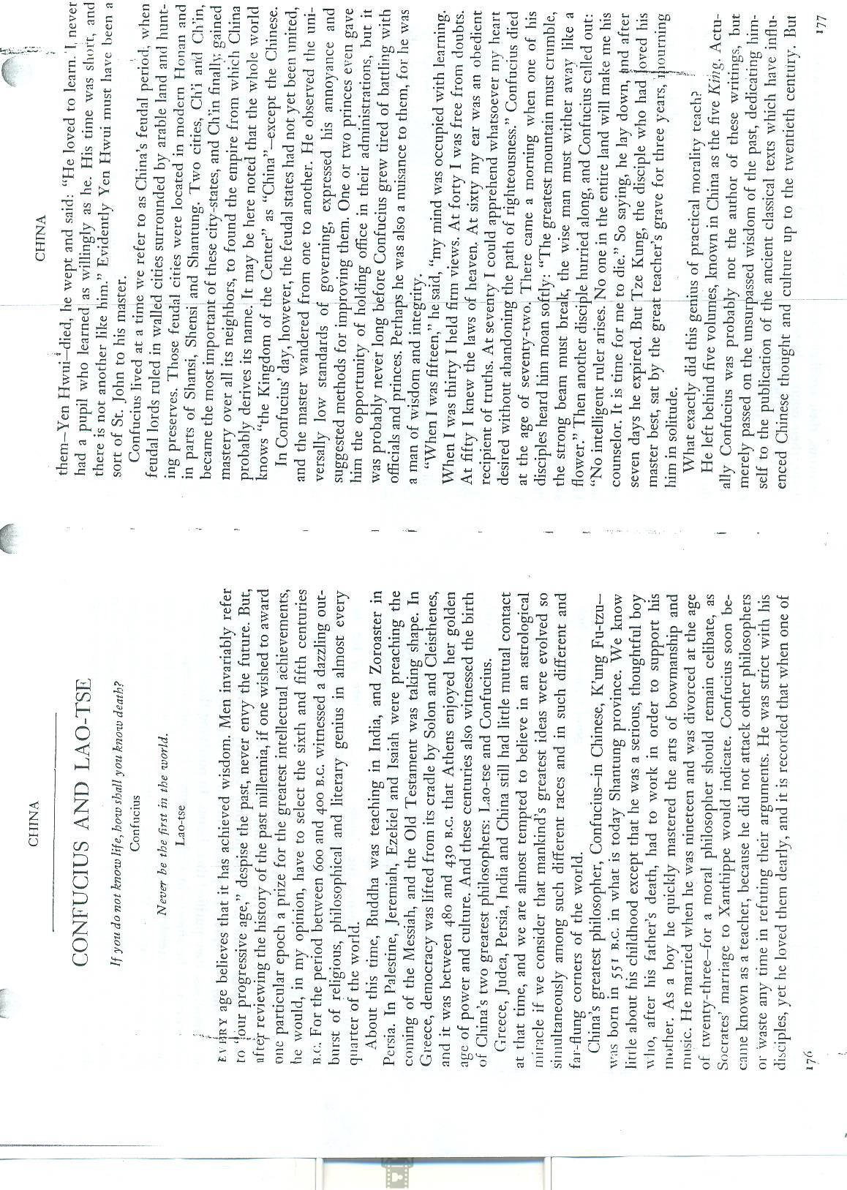
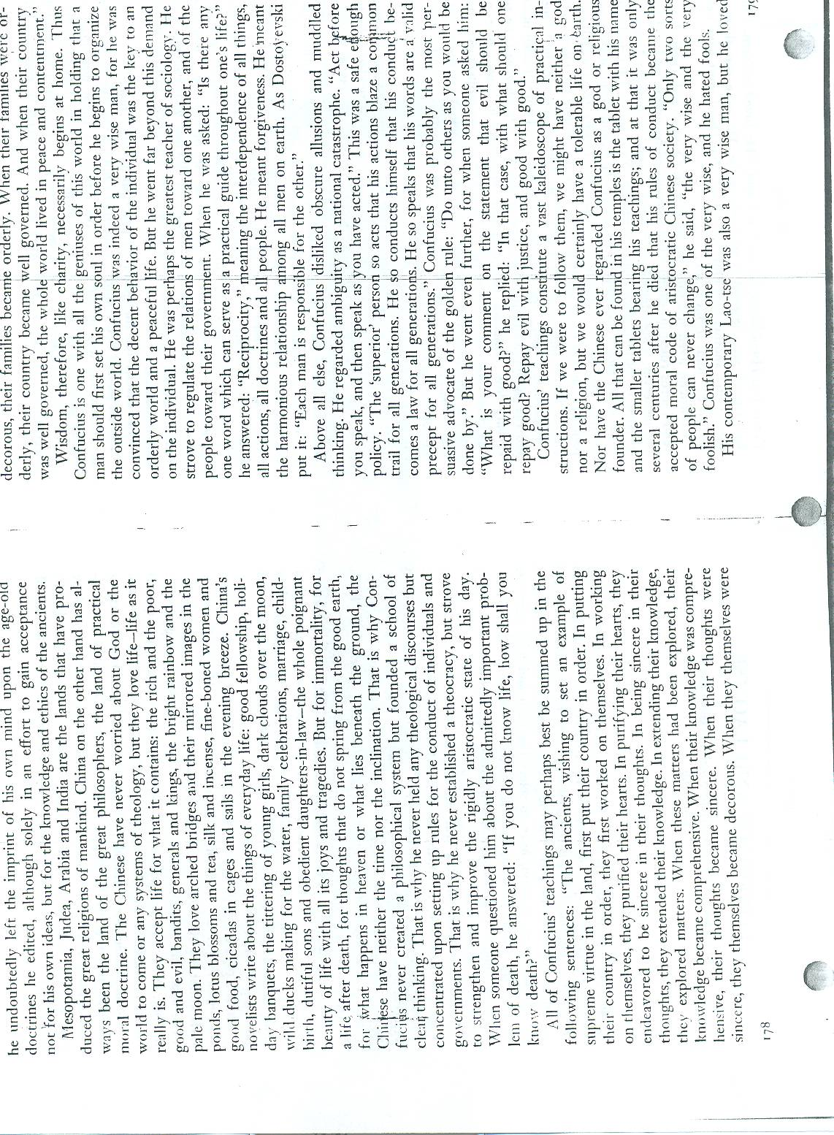
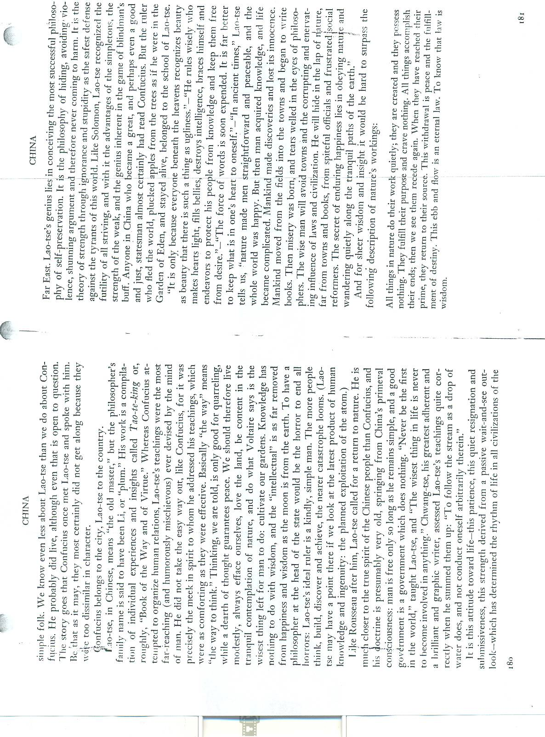
RCC_Taoism_3.1
NAME: ____________________________________________________________ DATE: _____________

Confucius and Lao-Tse Article Discussion Questions

1. What happened in the 5th and 6th century that was so dazzling?

2, What were some of the issues Confucius had as he observed the world around him?

3. How did Confucius’s views change as he grew up?

4. How were the Chinese different from the people in Mesopotamia, Judea, Arabia and India?

5. How does this distinction between China and the other places affect their views?

6. What did Confucius contribute to Chinese thinking?

What does government have to do with living?

8. What is the goal of Confucius’s philosophy?

9. Which other religious views would support Confucius treatment of other people?

10. Are his goals achievable or outrageous? Why do you think so?

11. What makes Confucianism more of a philosophy rather than a religion?

12. Why does Confucius belong to the city and Lao-Tse to the country?

(The line about the atom is incorrect; this article was written in the 1940s.)

13. Can you give an example where a “wait and see attitude” could be useful?

14. Can you give an example where a “wait and see attitude” could be harmful?

15. According to Lao-Tse, why is nature so important to his views?

16. How does the quote “If you do not know life, how shall you know death” relate to Confucius?

17. How does this quote “Never be first in the world” relate to Lao Tse?

RCC_Taoism_3.2

Module 1, Lesson 1: Confucius and Lao-Tse Article Discussion Answers

1. What happened in the 5th and 6th century that was so dazzling?
Burst of religious, philosophical and literary genius around the world without knowledge of it happening in other places, humanity’s conscious waking up.

2, What were some of the issues Confucius had as he observed the world around him?

He saw low standards of governing, never rose in politics.

3. How did Confucius’s views change as he grew up?
Young he learned, thirty had strong views, forty free from doubts, fifty got metaphysics, sixty knew the truth and seventy listened to his heart – overall his views changed and he understood more.

4. How were the Chinese different from the people in Mesopotamia, Judea, Arabia and India?
The Chinese didn’t worry @ God or the world to come, they thought about life as it really was.

5. How does this distinction between China and the other places affect their views?
Focus is different and therefore their purpose for life changes, creates relativity in terms of values.

6. What did Confucius contribute to Chinese thinking?
He created a school of thinking, rules for conduct and roles for govt.

7. What does government have to do with living?
Enforce societal norms, create structure for society, institution for setting the example, doling out consequences.

8. What is the goal of Confucius’s philosophy?
To have the world full of peace and contentment, wanted to regulate relations between people, wanted people to treat others as they wanted to be treated.

9.What other views would support Confucius treatment of other people?

Golden Rule, Jewish & Christian ethics
Interdependence is Buddhist too, there is no self only part of bigger picture.

10. Are his goal achievable or outrageous? Why do you think so?

Subjective

11. What makes Confucianism more of a philosophy rather than a religion?
There is no god, but a set of ethics that guide the believers.

12. Why does Confucius belong to the city and Lao Tse to the country?

Confucius’s doctrine are about how to treat others, live to make society better, Lao Tse’s views are about living simply, cultivate own gardens, living like the natural world.

(The line about the atom is incorrect: this article was written in the 1940s.)

13. Can you give an example where a “wait and see attitude” could be useful?

Subjective - Doing Dishes, sometimes letting a grimy dish sit and soak for an hour is better that spending 30 minutes scrubbing and not getting results.

14. Can you give an example where a “wait and see attitude” could be harmful?

Subjective- Things can pass you by if you are not assertive, if you don’t apply to colleges, won’t get in, need to put your self out there.

15. According to Lao-Tse, why is nature so important to his views?

World is happy and peaceful, knowledge made this complicated, ignorance is bliss, corruption came when men were in cities.

16. How does the quote “If you do not know life, how shall you know death” relate to Confucius?
Reflects his view that people should work on themselves and their relationships in life then good will come, doesn’t have views of death only how society should be.

17.How does this quote “Never be first in the world” relate to Lao Tse?
His views were about being simple, living in nature, being first may not be natural or go with the flow.

Lesson Four: The Middle Path - Buddhism in China
Objectives
- Students will describe the basic underpinnings of Chinese Buddhism
- Students will analyze a variety of different texts to formulate accurate descriptions of Buddhism in contemporary Chinese society.
Materials
- Projector
- PowerPoint [RCC_Buddhism_4]
- Photo Analysis Worksheet [RCC_Photographic_Analysis]
- RCC_Reading_4.1
- RCC_Reading_4.2
- Markers
- Chart Paper

Procedure
- Present PowerPoint/Lecture
- Conduct photographic analysis and solicit student reactions
- Break class into two groups and distribute articles
- Utilizing Penn Literacy techniques instruct the students to silently read articles
- Identify a student leader in each group to facilitate group discussion
- Have each group outline the lessons learned from assigned article on chart paper
- Brief student presentations

Lesson Five: Islam and Christianity in China
Objectives
- Students will understand and describe the basic characteristics of Islam and Christianity
- Students will analyze information and make inferences regarding religious culture around the globe
Materials
- Markers
- Chart Paper
- Islam Christianity PowerPoint [RCC_Christianity_Islam_5]
- Projector

Procedure
- Facilitate KWL Charts for Islam and Christianity
- Divide students into teams and have them compete against one another to answer the glass generated “what” questions
- Student teams will provide the answer along with annotated citation that comments on source authority
- Student outputs
- Brief Lecture/Slideshow

Lesson Six: Poster Project
- This culminating assignment is an opportunity for the students to investigate Islam and Christianity in contemporary China. It goes beyond retelling facts as the students are being asked to synthesize material and to make inferences about the state of religion in China.
Objectives
- Students will create digital poster exploring the state of Islam and Christianity in contemporary Chinese society
- Students will access a variety of resources to extract information and draw conclusions specific to their poster topic
- Students analyze information and make inferences regarding Chinese culture
Procedure
- Handout the Comparative Worldviews and have the students read the descriptions of the Western and Eastern worldviews. Facilitate a class discussion defining characteristics of each worldview[RCC_Worldview_6.1]
- Pair Share Activity-As a class or as a pair share have the students decide which statements support the Western worldview and the Eastern one
- Student Generated Statements-Give each student two note cards and have them generate two statements. Collect the cards and have the students guess which is which. Ask the students at the end to sum up the different world views. West-mechanical, split East- all is one
- Distribute Rubric/Checklist and outline expectations
- Provide appropriate amount of student work time
Gallery Walk – Suggested Activity
- Divide students into appropriate groupings
- Distribute [RCC_Poster Gallery Walk_6.2]
- Students present posters and answers questions as needed
- Distribute Student Tracking Sheet to facilitate accountability [RCC_Poster Gallery Walk_6.3]

Resources
General
"Survey Finds 300m China Believers." BBC News. BBC, 02 July 2007. Web. 11 Aug. 2012. <http://news.bbc.co.uk/2/hi/asia-pacific/6337627.stm>.
"White Paper - Freedom of Religious Belief in China." The Embassy of the People's Republic of China in Washington, DC. People's Republic of China, 1997. Web. 15 Aug. 2012. <http://www.china-embassy.org/eng>.
Wu Jiao. "Religious Believers Thrice the Estimate." Religious Believers Thrice the Estimate. China Daily, 7 Feb. 2007. Web. 23 Sept. 2012. <http://www.chinadaily.com.cn/china/2007-02/07/content_802994.htm>.=
Buddhism
"Buddhism." World Religions Reference Library. Ed. Julie L. Carnagie, et al. Vol. 1: Almanac. Detroit: UXL, 2007. 87-117. Gale Virtual Reference Library. Web. 15 Nov. 2012.
Ebrey, Patricia Buckley. "Buddhism in China." Buddhism. University of Washington, n.d. Web. 1 Nov. 2012. <http://depts.washington.edu/chinaciv/bud/5budhism.htm>.
Foy, Geoff. "Buddhism in China." Asia Society. Asia Society, n.d. Web. 5 Sept. 2012. <http://asiasociety.org/countries/religions-philosophies/buddhism-china>.
Lin, Gu. "Buddhist Prayers Jolt Chinese." Latitude News. N.p., 16 Jan. 2012. Web. 25 Oct. 2012. <http://www.latitudenews.com/story/buddhist-prayers-jolt-chinese/>.
Li Jing, You Xiaoying. "The 5-minute Hangzhou Guide." CNNGo.com. CNN, 3 Oct. 2011. Web. 3 Nov. 2012. <http://www.cnngo.com/shanghai/visit/explore-hangzhou/5-minute-complete-guide-hangzhou-264633?page=0,5>.
MacLeod, Calum. "USA TODAY." USATODAY.COM. USA Today, 2 Nov. 2011. Web. 15 Nov. 2012. <http://usatoday30.usatoday.com/news/religion/story/2011-11-01/tibetan-buddhism-china-communist-tension/51034604/1>.
Confucianism
Boltz, Judith Magee. "Laozi." In Encyclopedia of Religion. 2nd ed. Edited by Lindsay Jones. Detroit, MI: Macmillan Reference USA, 2005, 5315-20.Islam
"Confucianism." World Religions Reference Library. Ed. Julie L. Carnagie, et al. Vol. 1: Almanac. Detroit: UXL, 2007. 151-176. Gale Virtual Reference Library. Web. 15 Nov. 2012.
TATLOW, DIDI KIRSTEN. "Tapping Into a More Moderate Islam — in China." IHT Rendezvous. New York Times, 9 Oct. 2012. Web. 11 Oct. 2012. <http://rendezvous.blogs.nytimes.com/2012/10/09/tapping-into-a-more-moderate-islam-%e2%80%94-in-china/>.
Daoism
"Daoism." World Religions Reference Library. Ed. Julie L. Carnagie, et al. Vol. 1: Almanac. Detroit: UXL, 2007. 177-206. Gale Virtual Reference Library. Web. 15 Nov. 2012.
Johnson, Ian. "The Rise of the Tao." The New York Times. The New York Times, 07 Nov. 2010. Web. 20 Oct. 2012. <http://www.nytimes.com/2010/11/07/magazine/07religion-t.html?pagewanted=all>. [RCC_Appendix_3.1]
Littlejohn, Ronnie. "Internet Encyclopedia of Philosophy." Daoist Philosophy. Internet Encyclopedia of Philosophy, 12 July 2005. Web. 20 Aug. 2012. <http://www.iep.utm.edu/daoism/>.
"Taoism at a Glance." BBC News. BBC, 24 Aug. 2009. Web. 7 Nov. 2012. <http://www.bbc.co.uk/religion/religions/taoism/ataglance/glance.shtml>.

