Buddhist Prayers Jolt Chinese
By Lin Gu
January 16, 2012
There are many images that could compete for a “2011 photo of the year” award in China. But few would have bet that the picture of an unknown monk praying over a dead man would turn out to be among the most popular.
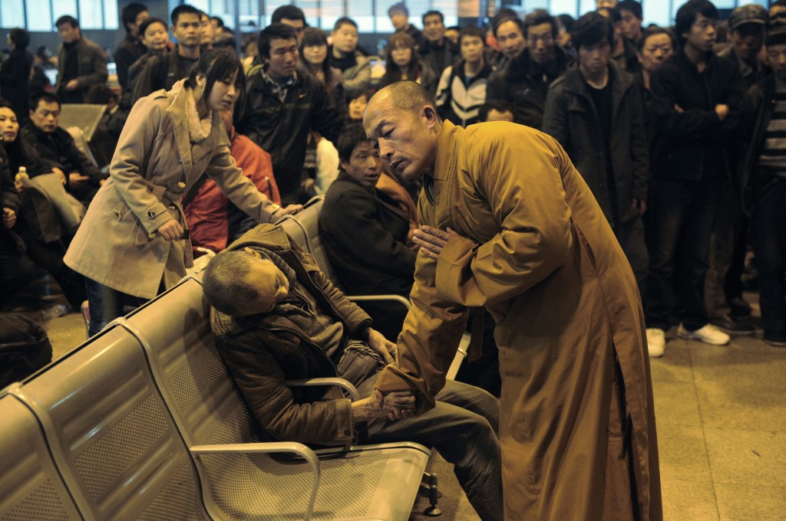
Taiyuan Train Station, Shanxi, November 25 2011 (REUTERS/Asianewsphoto)
It was on November 25 that an old man was found dead in the waiting hall of a train station in Taiyuan, the capital city of North China’s Shanxi Province. Among his fellow passengers was a Buddhist monk. Photos of the monk holding the dead man’s hand, bowing and praying for his final peace became overnight hits online. It was this image that was voted – by 58% of respondents to the popular Phoenix TV network – the most important Buddhist event of the year
Monks’ uneasy role in Chinese society
Monks have not had an easy time in China in recent years. Under communism many were forced to disrobe, others quietly retreated into obscurity. A Buddhist revival began in the late 1970s with the opening up the country but sensationalist media coverage of the lavish lifestyle of some monks soured many people’s view of them.
This scene in the Taiyuan train station, however, struck a chord with Chinese all over the country.
One netizen put it this way on the Phoenix TV site: “Previously Buddhist monks seem to follow a monastic daily routine with no direct contribution to the society. However, in face of life and death, I’m so touched to see this peace and courage coming from a Buddhist monk compared to those bystanders who either folded their hands or try to flee the scene in fear. This profound concern for people gives one hope that one can reconstruct morality in our society.”
Take another look at those bystanders. They don’t look afraid. What strikes me is their bewilderment and indifference.
Now contrast them with another group of Chinese bystanders at an incident that became notorious the world over.
The risk of being a Good Samaritan
On October 13 in the southern Chinese city of Foshan Yue-yue, a two-year old little girl, was knocked over first by one van and then hit by a second without anyone coming to her aid. Over 7 excruciating minutes – all caught by surveillance cameras – a total of 18 people just walked by the girl, lying in a pool of blood. It was the 19th, an elderly garbage collector who came to her rescue. After seven days in intensive care, Yue-yue still died of severe injury.
The surveillance video spread like wild fire, attracting media attention around the world and fanning more flames of outrage. The local communist party newspaper, Foshan Daily, was just as emotional: “This Day They Have Shamed Whole City of Foshan” ran its front page headline.
Is it fair to see the Yueyue tragedy as an indicator of wider moral bankruptcy in China? After all, there are also many stories of strangers helping each other. “There have always been good hearts in this society, no doubt about that, but [what we see here] is a real danger, the danger of apathy,” said the renowned sociology professor Zhang Ming on a TV talk show discussing this particular incident.
Interestingly, in the same TV talk show, when asked whether they would help should they see a little girl bleeding on the street, half of the audience didn’t raise their hands.
For anyone living in China today the reason for this reluctance is obvious. If you help, you may well face extortion demands from the victim or his/her family. The story – often repeated in the media – is always the same. The Good Samaritan loses out financially and legally. And the lesson is clear: don’t help strangers. Ever.
Is collective apathy the problem?
But not every commentator buys this argument. In a razor sharp editorial, the official Yangchen Evening News in Guangzhou, one of China’s most popular evening newspapers, pointed out that “the choice of the 18 passersbys has nothing to do with the ‘wronged good person’ phenomenon. It is because of the indifference and cowardice deep down in their souls.” It is collective apathy, the editorial argued, that has led to the repeated victimization of good Samaritans. And they called on everyone to reach out once again to the Little Yueyue lying in blood, “not just to save her, but to redeem ourselves”.
It was in this charged atmosphere, a little over one month after Yue-yue’s death, that the monk offered a different response to human suffering: compassion.
“In this harsh survival game in the city jungle, everyone is rushing, leaving no time for even a glance to see who is out there in need of their help. Any time they do have, they have to use to lick their own scars,” is the way the venerable Long Zang, vice president of the newly opened (March 2011) Henan Buddhist College told me in an exclusive interview. “Love and compassion needs enough space to nurture.”
“We all could be one of the 18 passersby. And like the unfortunate girl, the 18 also merit our sympathy,” he concluded.
Click to hear chanting from the Henan Buddhist College:
I also quietly asked myself, would I fold my hands or rush to rescue Yue-yue if I had been in the city of Fashon that day? Or put it another way, how many times have I given to a beggar, a much less visually disturbing presence than the bloodied Yue-yue? And if so, have I ever stopped and looked into his eyes to try to listen to his story? Maybe, but only if I want to write a story about begging in China.
Time is a luxury, even for professional charity workers.
Compassion needs space
In my very first trip to the U.S. in 2000, I met a recovering drug addict who was receiving therapy and other help from a big charity organization in Dallas. When I asked him his impression of the staff workers in the organization, he didn’t even bother to hide his disappointment. “They only talk to you in office hours,” he said, shrugging his shoulders.
The praying monk at the train station, in other words, came along at a moment with Chinese society is both disillusioned and yearning for something positive. He exemplified a return to humanity and basic compassion.
“He symbolizes an ideal version of what a monk, or a man should be. He gives me a sense of warmth,” says Liu Xiaocun, an editor based in Beijing.
As for the man who has inspired this warmth, no-one has a clue as to who he is and where he is now.
That too is fitting. Traditionally, a monk is not allowed to shelter under any one tree for more than three days. He is supposed to wander so as to avoid worldly attachments.
The one thing that is sure is that – wherever he is – he will keep on praying.

