Chinese parents defrauded by 'perfect' education
Parents in China 'cheated' by summer course claiming to allow children to read books in 20 seconds

- Tania Branigan, Beijing
- The Guardian, Tuesday 28 August 2012 11.04 EDT
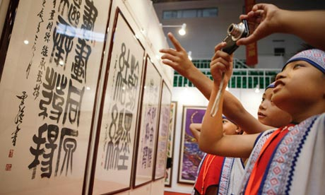
Parents were told by a Shanghai summer course that their children would be taught to read a book in just 20 seconds. Photograph: Wang Ying/Xinhua Press/Corbis
For ambitious Chinese parents, the opportunity was too good to miss – even with its 100,000 yuan (£9,950) price tag. Their children would learn to read books in 20 seconds and identify poker cards by touch. The most talented would instantly see answers in their heads when presented with test papers.
Around 30 pupils aged from seven to 17 were enrolled for the Shanghai summer course. But 10 days later their "special abilities" had not materialised. "I found that my child learned nothing except how to cheat," one parent complained.
Experts say the bizarre programme's popularity was simply an extreme example of how families seek to help their children in the intensely competitive education system. Chinese parents have long focused on the college entrance exam, the gaokao. Now families say they are caught in a chain, because good gaokao results depend on getting into a good high school, which, in turn, requires a good primary. Even some nursery schools in big cities have waiting lists and interviews.
After-hours classes, weekend tutoring and summer courses are common before middle-class children hit their teens. Few are quite as spectacular as the Shanghai programme, which claimed it achieved remarkable results by training children to use the right-hand side of their brain. A tutor told an undercover reporter from the Oriental Morning Post that pupils learned to detect "certain waves" that emanated from everything, including words.
Those waves were "recorded in their brains as pictures" so that they could read without even looking, she added. Police are now investigating the company behind the course.
One angry father told the Guardian the teachers had convinced his daughter she really could read cards by touch. Though his tests proved her wrong, other parents were reluctant to accept the truth, he said. The case underlines the lengths to which parents will go to give their children a competitive edge, or simply help them keep up.
Of the wider phenomenon, one Beijing mother, who has paid for extra English and maths lessons since her daughter was six – a year before she started primary school – said: "Every kid is going to after-school classes nowadays. It's not only kids who are not good at school but also top students."
Ms Wei, who asked that only her surname be used, said her previously carefree daughter was already showing signs of stress. "But what can we do? If she fails to get into a good high school, her future won't be bright," she added. "Kids have to fight fiercely in order to go to top schools. It's like a real battle with blood and bruises."
Such anxieties are widespread. Last year research by the Pew Global Attitudes Project found that China was the only country in which most people – 68% in all – thought parents put too much pressure on students. In contrast, 64% of Americans thought parents applied too little pressure.
Children seem to agree. A 2010 study by British and Chinese researchers found that more than a third of the primary school pupils they surveyed in the eastern province of Zhejiang suffered headaches and stomach pains at least once a week.
"The competitive and punitive educational environment leads to high levels of stress and psychosomatic symptoms," said the researchers, who were led by Professor Therese Hesketh of the Centre for International Health and Development at University College London.
Officials have already tried to curb some excesses. Earlier this year, Chinese media reported that the ministry of education had banned nursery schools from setting homework.
But parenting expert Yin Jianli, who urges families to value creativity and independence, said it was also time for fathers and mothers to grow up. She acknowledged that people worried about their sons' and daughters' futures, but added: "They won't let their children have a proper break during holidays. They know very little about education and child-rearing, but they have a strong sense of being competitive. So they will just follow other parents blindly." That was not just tough on the children, but counter-productive, she warned: "In the short term, kids will feel tired. In the long run, they will lose their interest in studying."
Additional research by Kathy Gao

